SOURCE CODE FOR DETECTION OF DOS, DDOS AND BOTNET ATTACKS :

#========================== IMPORT PACKAGES ============================

import pandas as pd

from sklearn import preprocessing

from sklearn.model_selection import train_test_split

from sklearn import metrics

from sklearn import linear_model

import warnings

warnings.filterwarnings('ignore')

* Now Extract the Network Packets From the Device Through Wireshark.
* Extract as Excel Sheet and Read that data.

dataframe=pd.read_csv("Bot-Iot.csv")

Print(dataframe)

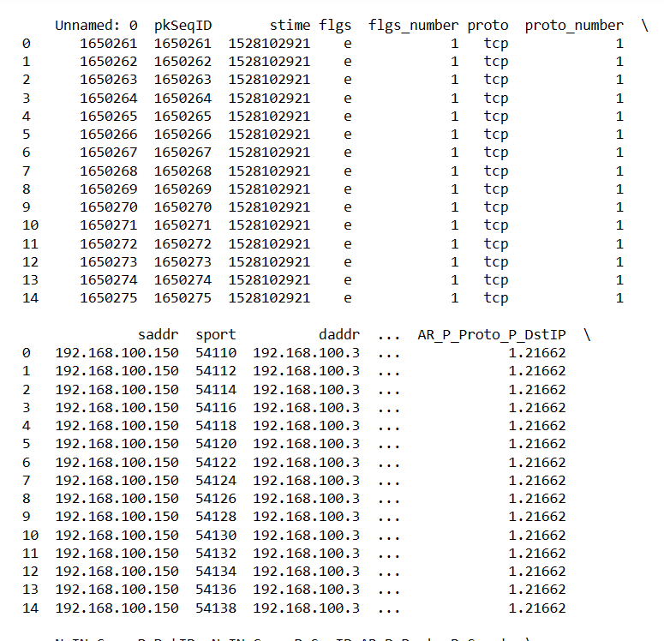

**# Checking Missing Values:**

print(dataframe.isnull().sum())

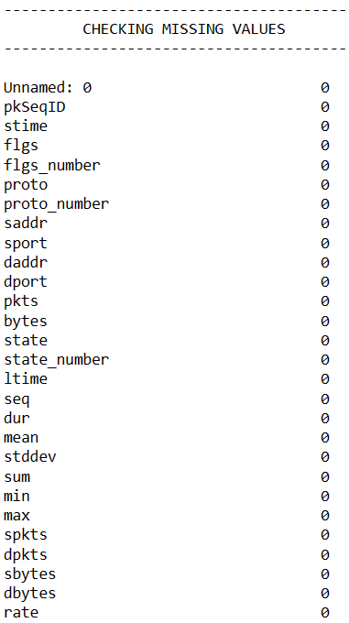

Label Encoding :

print("------------------------------------------")

print("           BEFORE LABEL ENCODING          ")

print("------------------------------------------")

print()

print(dataframe['category'].head(20))

label_encoder = preprocessing.LabelEncoder()

#dataframe['category'] = label_encoder.fit_transform(dataframe['category'])

#dataframe['proto'] = label_encoder.fit_transform(dataframe['proto'])

dataframe = dataframe.astype(str).apply(label_encoder.fit_transform)

print("------------------------------------------")

print("           AFTER LABEL ENCODING           ")

print("------------------------------------------")

print(dataframe['category'].head(20))

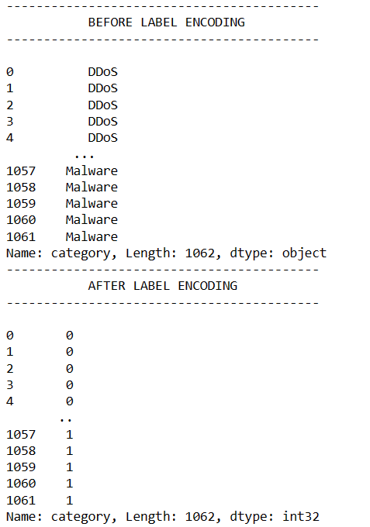

X_train, X_test, y_train, y_test = train_test_split(X, y, test_size=0.3, random_state=0)

**PCA :**

from sklearn.decomposition import PCA

pca = PCA(n_components = 4)

X_train1 = pca.fit_transform(X)

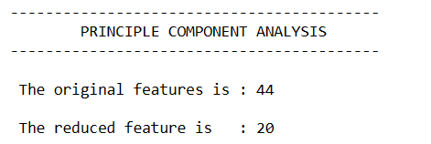

**Code For Detection :**

import numpy as np

from sklearn import metrics

from tensorflow.keras.layers import Input, Dense, Dropout, LSTM

from tensorflow.keras.models import Sequential

# Assuming X_train and y_train are the training data

# Reshape the input data to match the model's expected input shape

x_train = np.expand_dims(X_train, axis=-1) # Shape: (number_of_samples, sequence_length, 1)

# Build the LSTM model

model = Sequential()

model.add(LSTM(units=50, input_shape=(x_train.shape[1], x_train.shape[2]), return_sequences=True, kernel_initializer="uniform"))

model.add(Dropout(0.2))

model.add(LSTM(units=5, activation='relu', return_sequences=False))

model.add(Dropout(0.2))

model.add(Dense(units=3, activation='relu'))

model.add(Dense(units=1, activation='sigmoid')) # Sigmoid for binary classification

model.compile(loss="binary_crossentropy", optimizer='adam', metrics=['accuracy', 'mae'])

model.summary()

# Train the model

history = model.fit(x_train, y_train, epochs=5, batch_size=2, verbose=2)

# Make predictions on the training data

y_pred_train = model.predict(x_train)

# Convert predictions to binary classes (0 or 1)

y_pred_train_classes = (y_pred_train > 0.5).astype('int').reshape(-1)

# Print actual and predicted values for comparison

print()

print("Actual :", y_train[:10]) # Print the first 10 actual values

print("Predicted:", y_pred_train_classes[:10]) # Print the first 10 predicted values

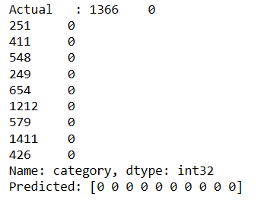

**# FINAL PREDICTION**

